**“SETUP DATABASE”**

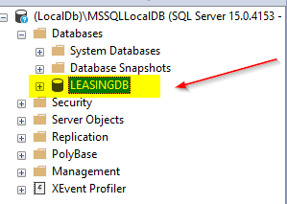NAME SHOULD BE : “LEASINGDB”

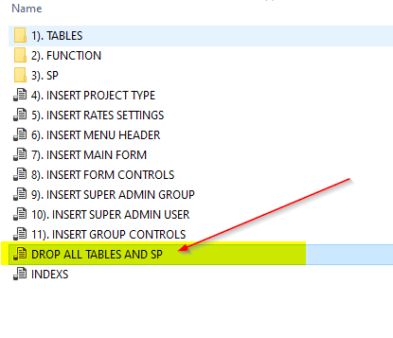

Note : DOWNLOAD THE SCRIPT FILE FROM GITHUB and Extract

*LEASING.UI.WIN\SCRIPTS\CALOOCAN SETTINGS*

CLEAN THE LEASINGDB TABLES AND SP AND FUNCTION :

Note :Drag or Open the following Script to Management studio Make sure your database is correct. execute the following scripts accordingly

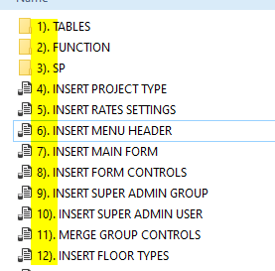

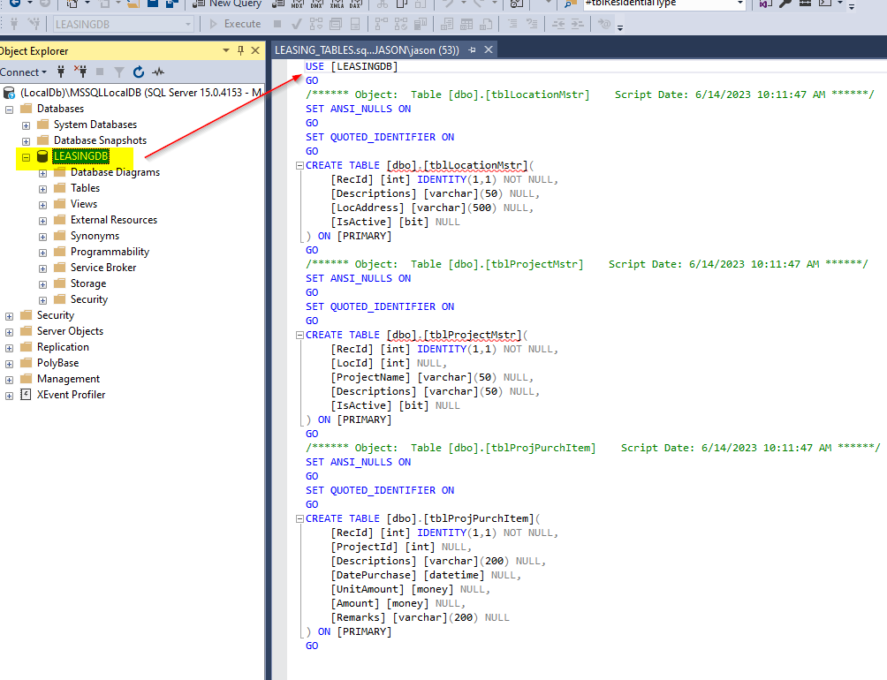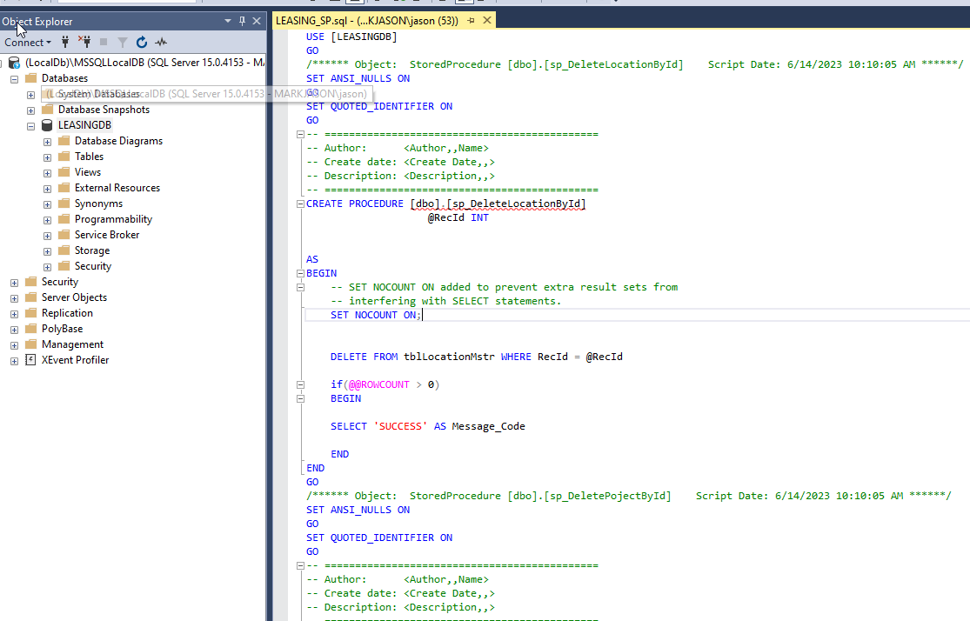

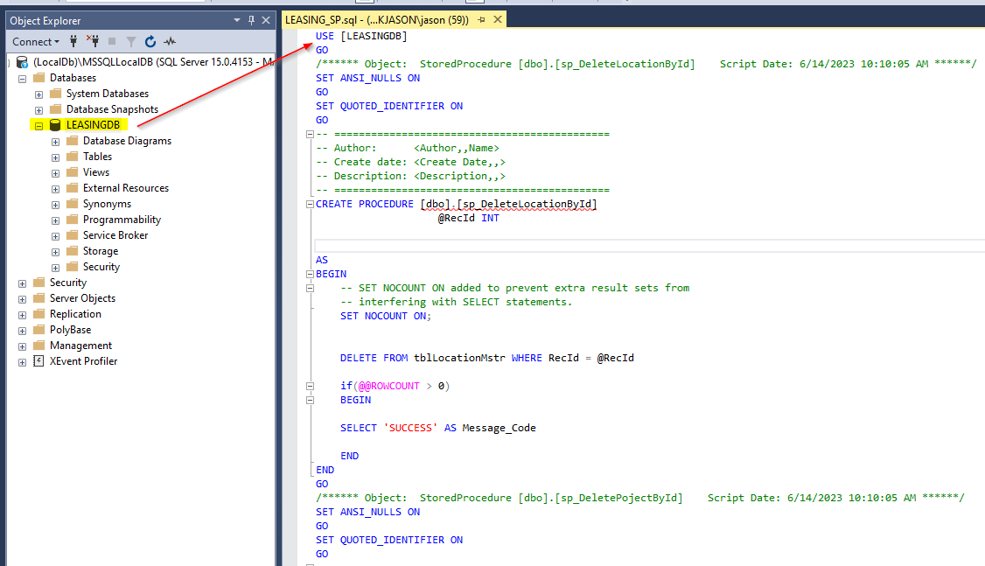

ONCE DONE VERIFY IF THE TABLES AND STORE PROCEDURE IS CREATED

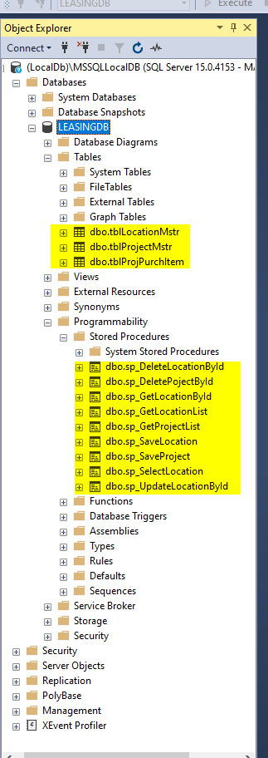Refresh the Database

SETUP EXECUTABLE : Please refer to the link : <https://github.com/xgenboy27/LEASING.UI.WIN.git>

And VIEW Instruction in the PDF FILE : GITHUB REPOSITORY

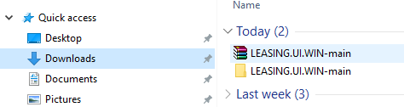

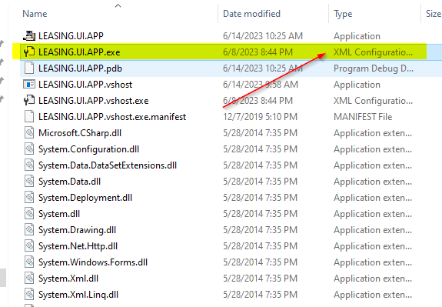EXTRACT THE FOLLOWING EXECUTABLE TO YOUR APPLLICATION DIRECTORY OR ANY DRIVE.

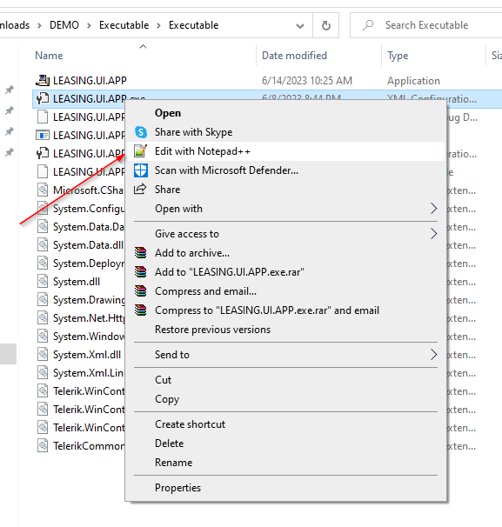

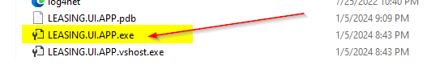

OPEN IN NOTEPAD OR ANY TEXT EDITOR

**“DATABASE CONNECTION”**

Note: Change the highlighted one to your current “SQL SERVER NAME”

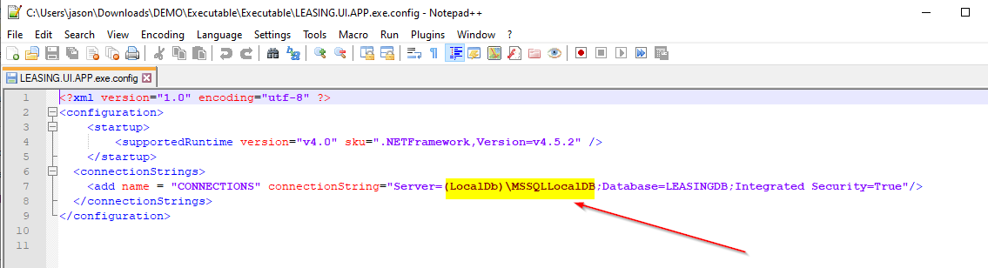

**“REPORT DIRECTORY”**

Note: Create a folder for REPORT “C:\REPORTS\” this folder will be the base of all report (‘Reciept’ & ‘Contract’)

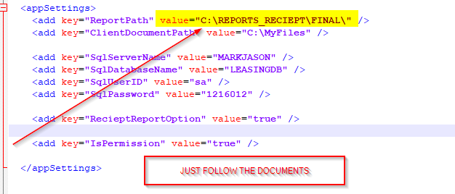

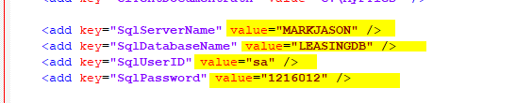

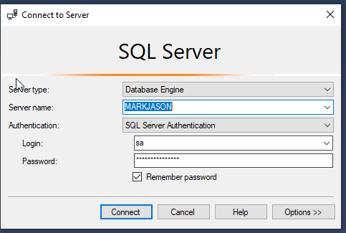

Note : Make sure you setup the database into : SQL Server Authentication

To check select the server name and right click then select properties

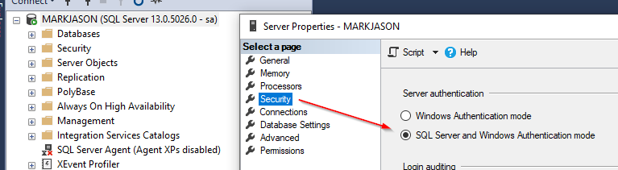

Note : And you have a database server user “sa” and set the password ,ex..

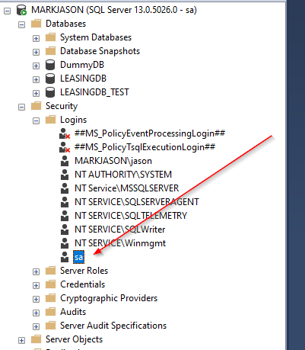

Once you done the setup please ..

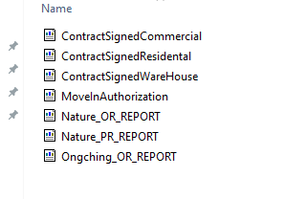COPY THE FILE FROM GITHUB OR DOWNLOAD

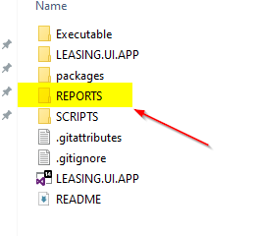

**“CLIENT FILE DIRECTORY”**

Note: Create a folder directory “C:\CLIENT_FILE”

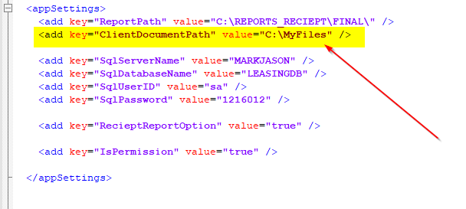

THEN Save

AND ” Run The application ”

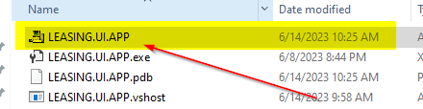

**“DEFAULT LOGIN”**

User to be user for creating all the setup : Location,Project,Unit,Rates,User Group,Users,User Permission

UserName : “admin”

Password: “admin”

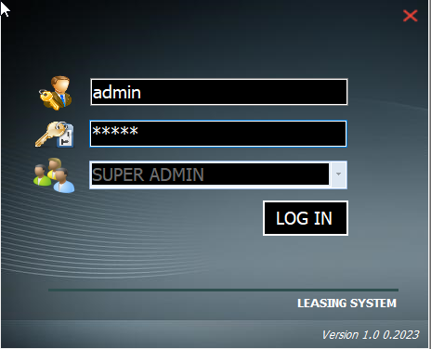

**“GENERAL SETTING”**

**1). UPDATE RATE SETTINGS**

**2). CREATE LOCATION**

**3). CREATE PROJECT**

**4). CREATE UNIT**

**5). CREATE BANK NAME LIST**